
Kathmandu College of Technology
Lokanthali, Bhaktapur

Lab report on
Mathematics-I
As required for the partial fulfillment of
BCA 1st Semester
Affiliated to Tribhuvan university

Submitted by Submitted to
Smriti Shrestha Department of BCA
Roll no: 25

TABLE OF CONTENTS

Lab No. | Report Title
1. | Realization of Function using Mathematica
2. | Realization of Matrix using MATLAB
3. | Realization of Circle, Ellipse, Parabola, Hyperbola using Mathematica
4. | Realization of Vector using MATLAB

LAB EXPERIMENT
NO.1
Function and Graph
Software used: Mathematica
Command used:
- Plot
- Inverse function
- Composite function
LAB EXPERIMENT
NO. 2
Matrix and Determinant
Software used: MATLAB
Commands used:
- Det (Determinant)
- Inv (Inverse)
- + (addition)
- - (subtraction)
- Transpose
- Rank
- Adjoint
LAB EXPERIMENT
NO.3
Scalar and Vector
Software used: MATLAB
Commands used:
- Norm(Magnitude)
- Cross (Cross Product)
- Dot (dot product)
- Scalar Triple product
- Vector triple product
LAB EXPERIMENT
NO. 4
Conic Section
Software used: MATHEMATICA
Commands used:
- Plot
- Show Graphics
- Contour plot
- Construct any three 3*3 matrices X, Y and Z and perform the following operation using MATLAB.
- det(A),det(B),det(C)
- Inv(A),Inv(B),Inv(C)
- A+B,B+C,C+A
- A-B,B-C,C-A
- Transpose(A)
- Transpose(B)
- Transpose(C)
- X*Y,Y*Z and Z*X
- Rank of X
- Rank of Y
- Rank of Z
Answer:
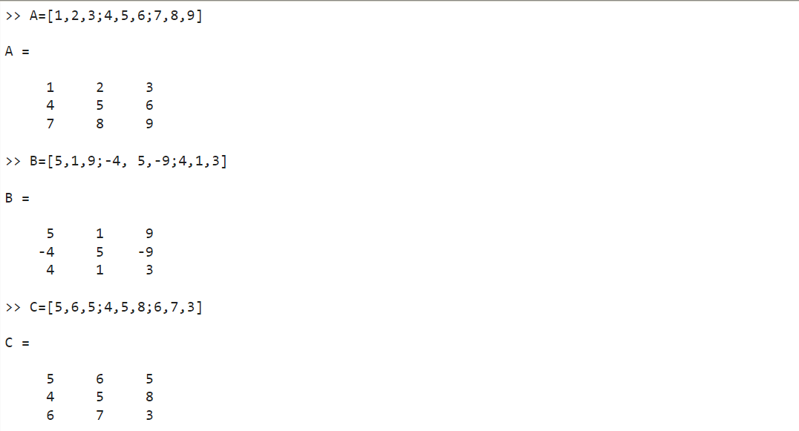

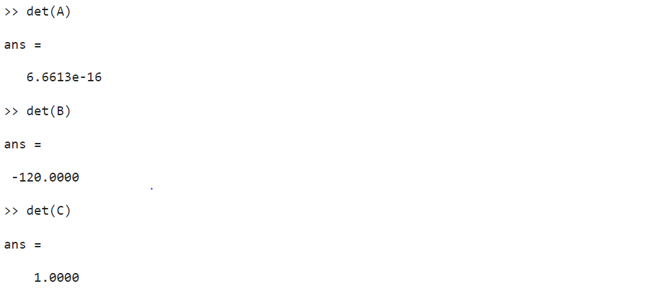
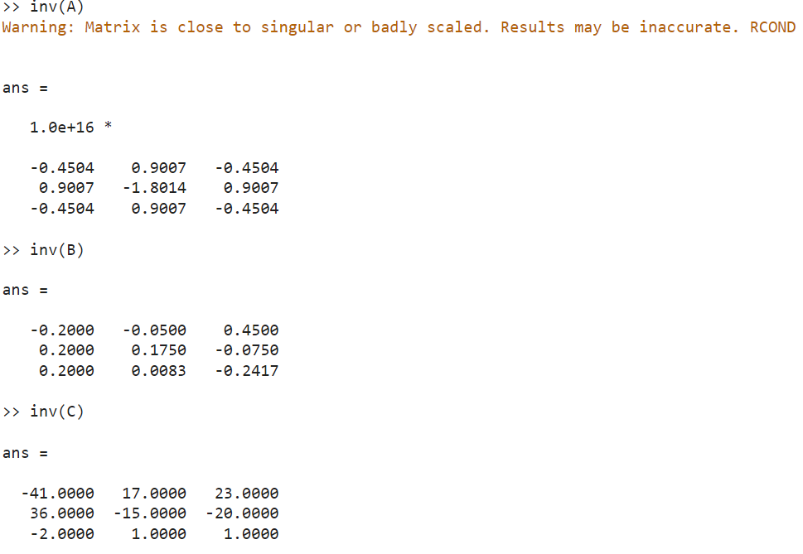
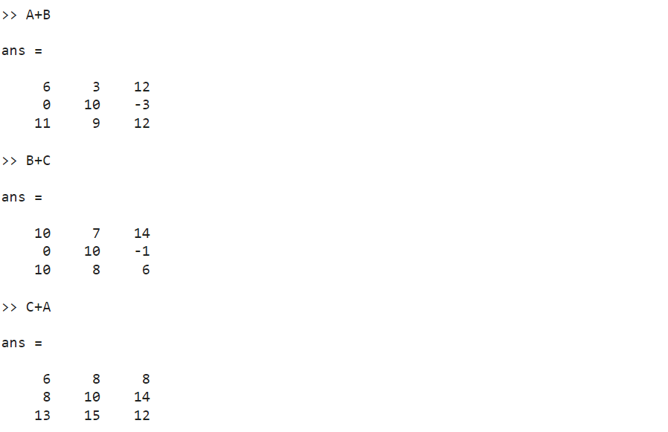

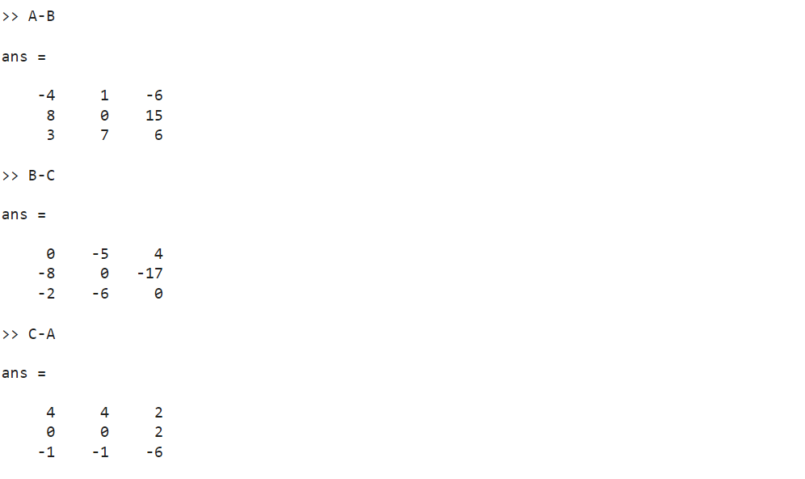
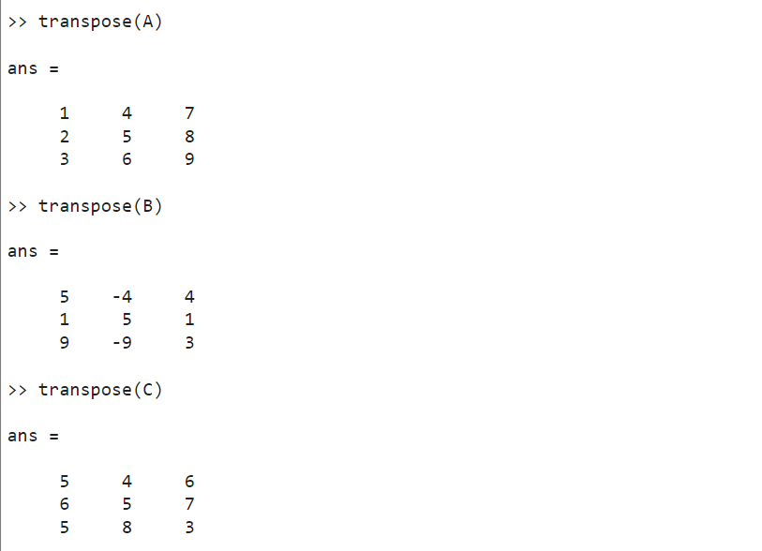

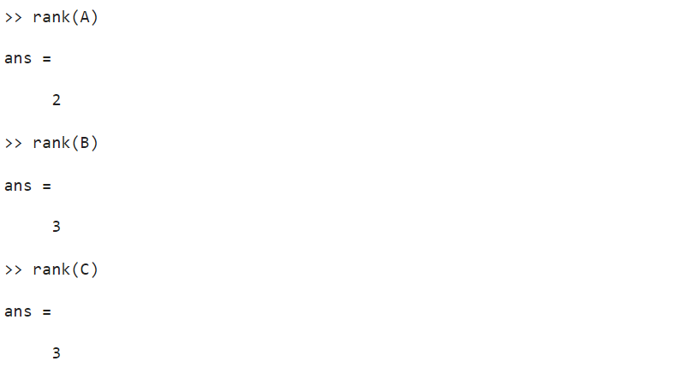
- Construct any three space vectors a, b, c and obtain the following result using MATLAB.
- Norm of each vector
- All possible dot product
- Scalar triple product of given vector
- Vector triple product of given product.

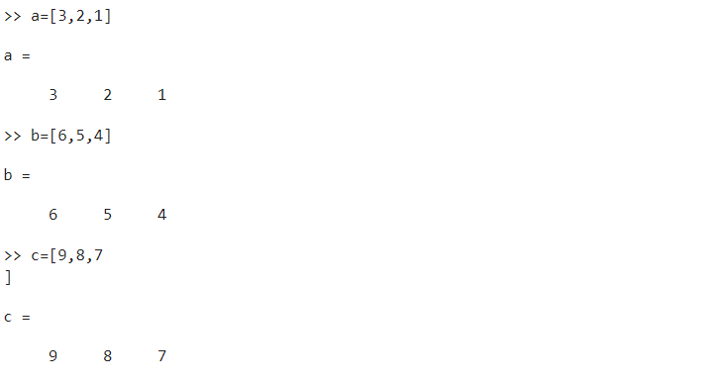
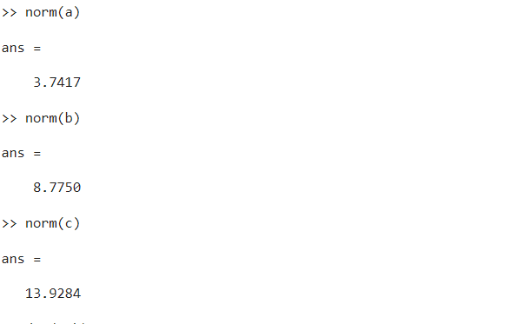

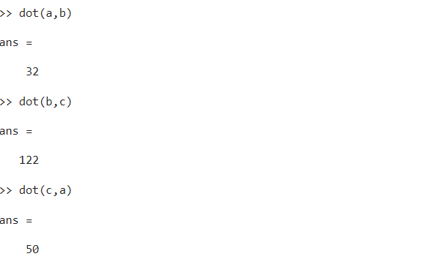

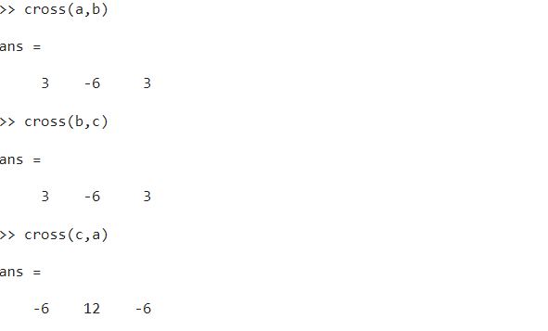
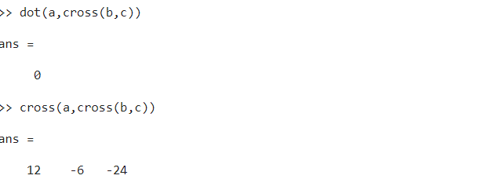
Plot circles having center (0,0) and radius
- 3
- 2
Answer:
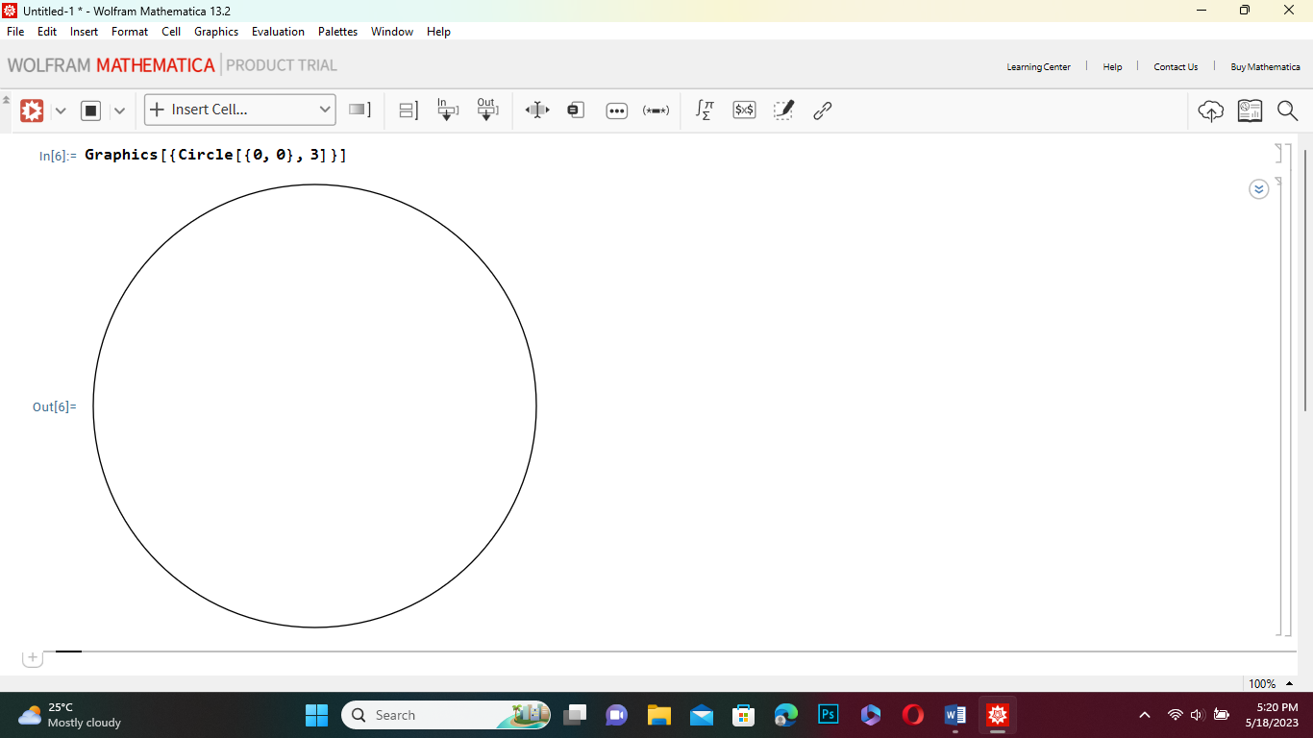

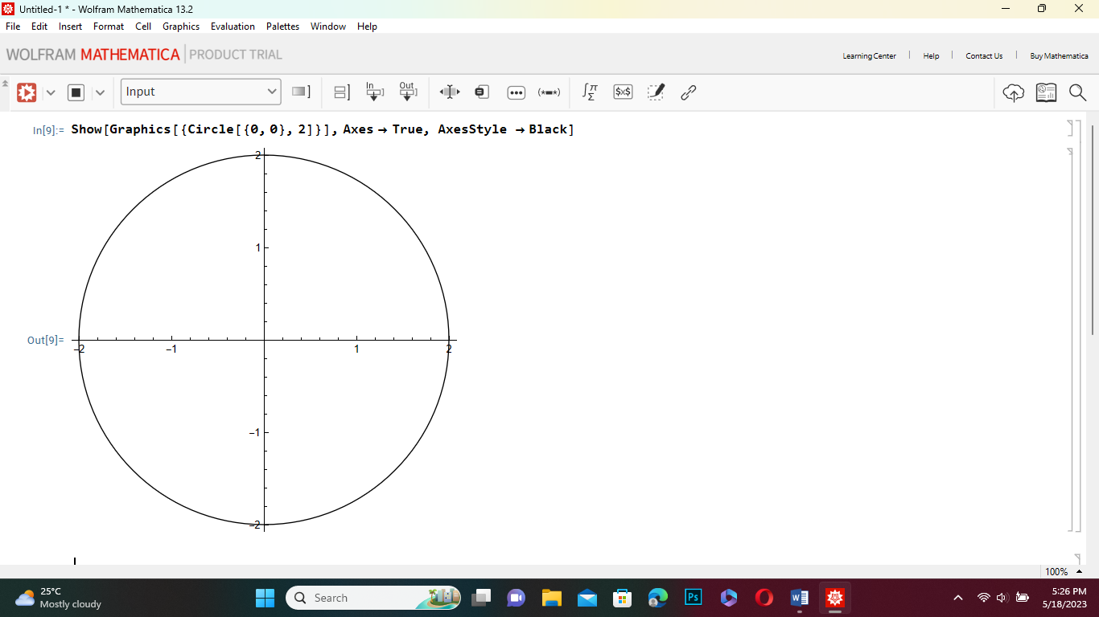

Plot a parabola x²+6x+10.
Answer:

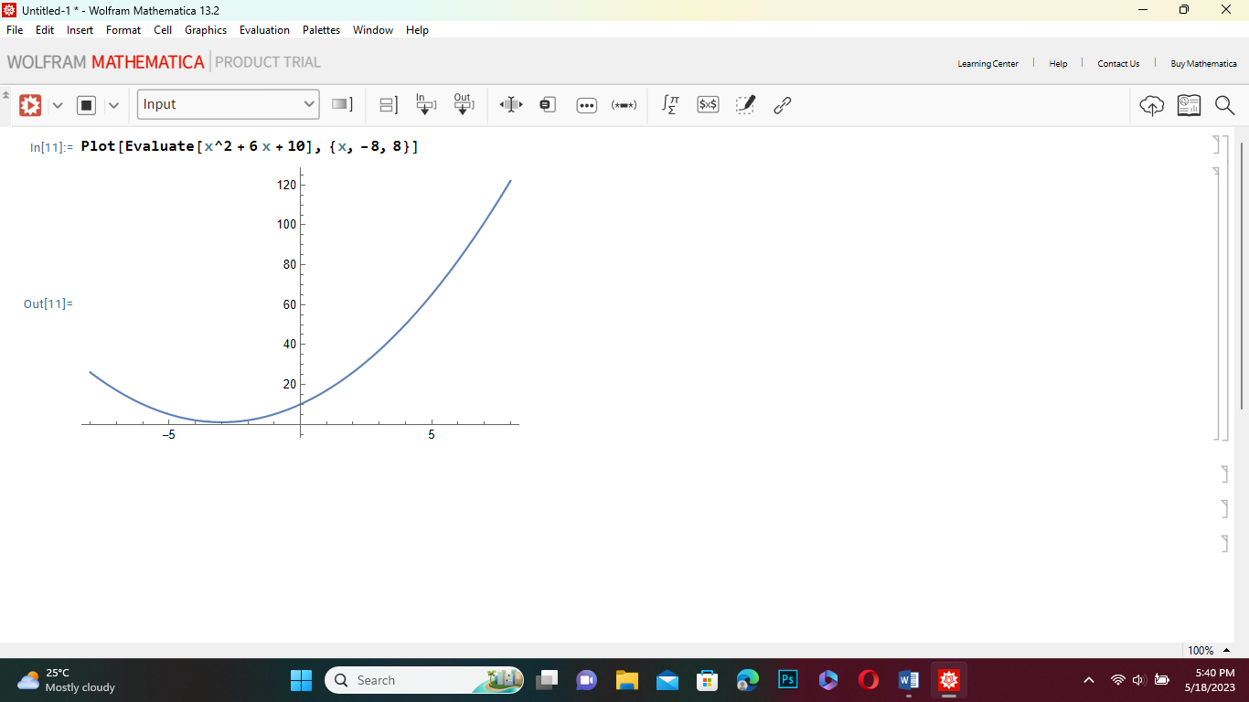
Plot a hyperbola y²-x²=1
Answer:

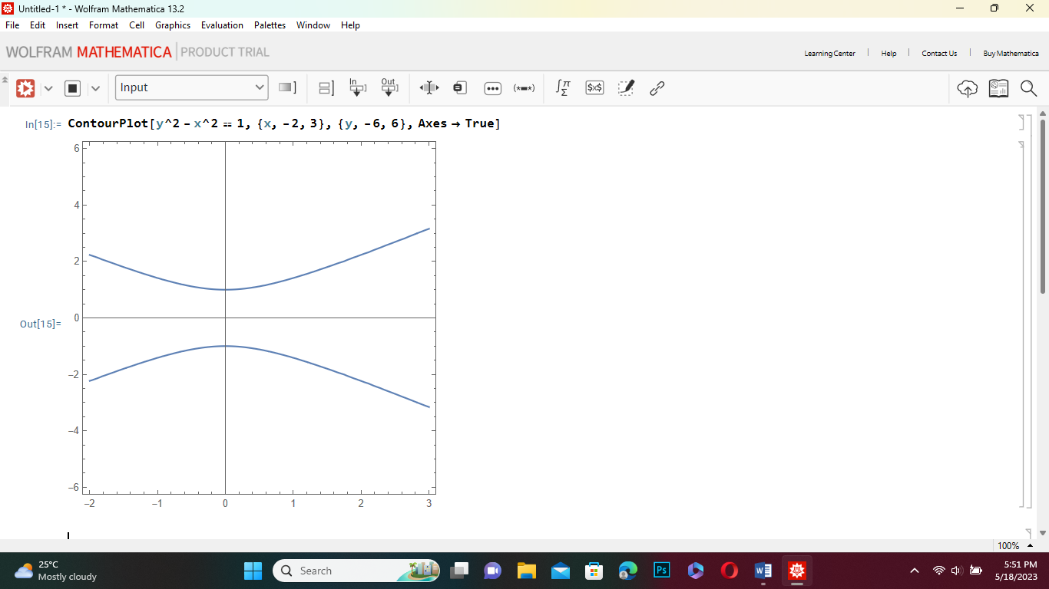

Let f: R→R defined by f(x)=2x+3, then find f(5).
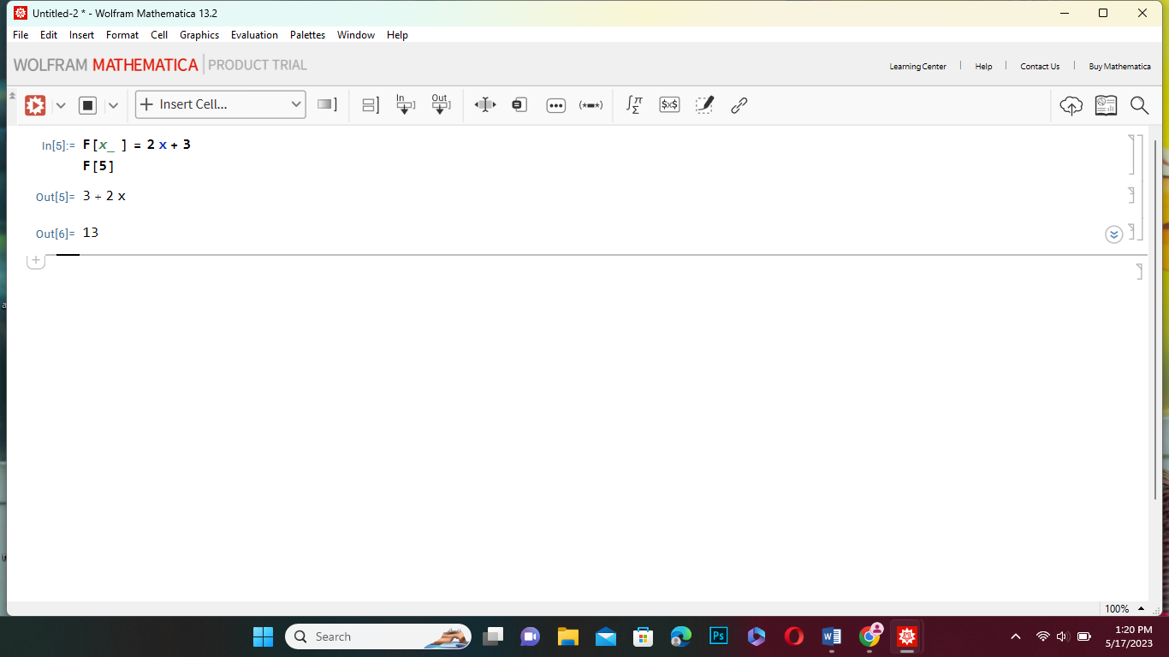

Let f: R→R define f(x)=2x+3 and g: R→R define by g(x)=x² ,then find fog(x) and gof(x) and plot it in a graph.
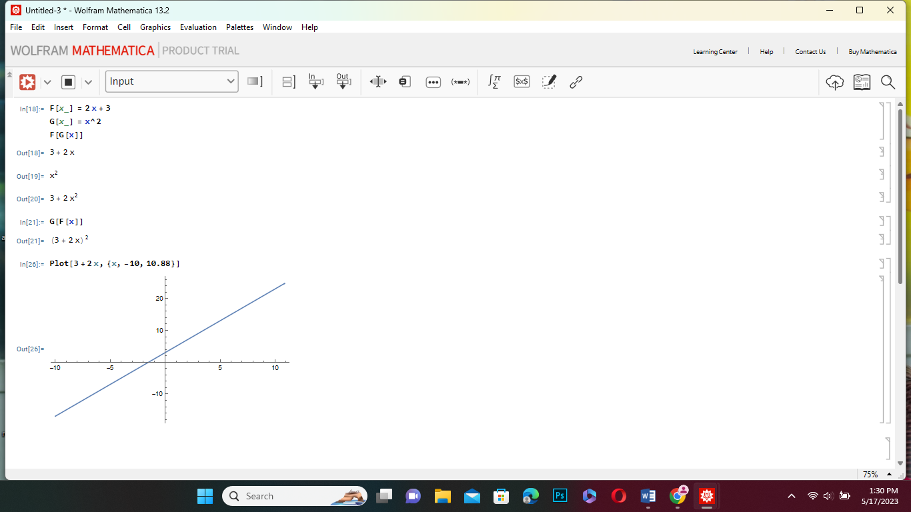
Let f:A→B define by f(x)=x²+2, where A=(1,2,3), then find range.
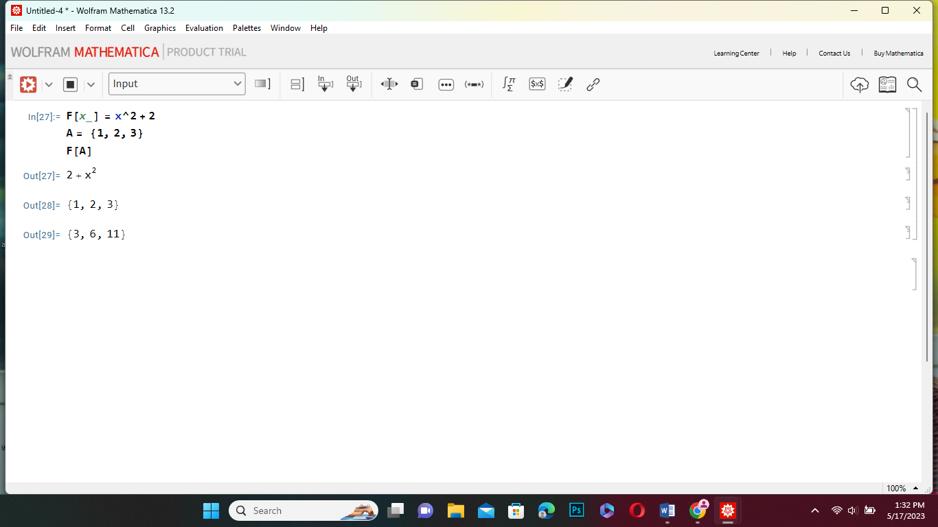
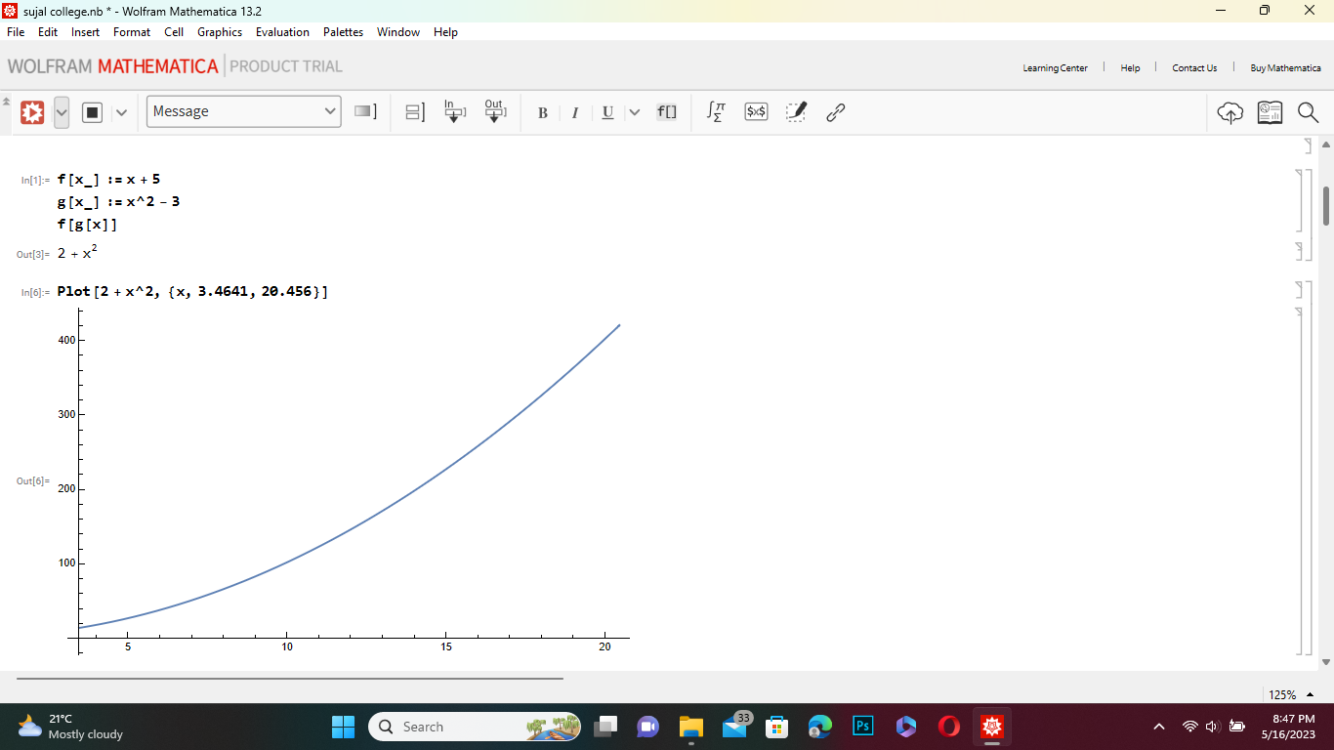
If f(x)= x+5 and g(x)=x²-3 then find (fog)(x)

If f(x)= x+5 and g(x)=x²-3 then find (gof)(x)

